

Session: 2024 -25
Minor Project
On
Name of the Topic
Internet of Things (IoT) in smart homes
Name of the Student
Sakshi Srivastava
University Roll Number
2110454010340
B.Sc.- VI Semester
Paper Code - MP
Submitted To – Dr Arvind Sharma
Department of Computer Science
Lucknow Christian College, Lucknow

CANDIDATE DECLARATION

I, Sakshi Srivastava (2110454010340) of Academic Session 2023-24, have carried out the work on Internet of Things (IOT) in Smart Homes for Minor Project of Mathematics in B.Sc-VI Semester,2023-24 from Department of Computer Science, Lucknow Christian College, Lucknow. The Matter embodied in this Minor Project has not been submitted by me to any other University or Institution forward of any degree/diploma/certificate.

SAKSHI SRIVASTAVA
51482
B.Sc.-VIth Semester
Lucknow Christian
College, Lucknow

Acknowledgement
Acknowledging the profound impact of IOT and its applications is essential in recognizing the contribution of countless researchers, analysts and engineers who have dedicated their efforts in advancing this transformative field. I extend my gratitude to the pioneers who laid the ground work for IOT in smart homes, unlocking its potential to revolutionize signal processing.
I am indebted to the scholars and practitioners who have tirelessly expanded the applications of IOT in smart homes across disciplines. Their work has not only shaped the foundations of communication system, image processing, and dealing with the real life problems but has also permeated into realms like alexa, smart bulbs, smart speaker etc .These things had made life easier and simpler.
Special acknowledgement goes to those who have developed innovative algorithms and computational techniques, addressing the challenges posed by real world, non- stationary signals. Their ingenuity has propelled the efficiency of smart homes, making them indispensable tools in handling vast data and pushing the boundaries of what is achievable.
In expressing my appreciation, I also recognize the collaborative efforts within the technological community, where the exchange of ideas and the collective pursuit of knowledge have driven the evolution and refinement IOT analysis and bringing up the concept of smart homes. Together, these individuals have left an indelible mark on the landscape of science and technology, and for that, I extend my heartfelt acknowledgement.

Contents
ABSTRACT 5
1. INTRODUCTION 5
3. What is IoT? 7
3.1 History of IoT 8
3.2 Features of IOT 10
3.3 IOT as Network of Networks 12
3.4 Advantages of IOT 12
3.5 Disadvantages of IOT 14
4. Smart Homes 15
4.1 Smart-Home Background Analysis 18
4.2 LITERATURE SURVEY 21
4.3 TECHNOLOGY USED IN SMART HOMES 25
4.4 How does smart home technology work? 30
4.5 IoT architecture and technologies 31
5. Application of IOT in Smart Homes 34
6. Major Trends in Global Smart Home Market 36
6.1 Major Technology Trends 37
7. Challenges and their solutions 39
8. Future scope of IOT in Smart Homes 44
9. Conclusion 45
10. BIBLIOGRAPHY 46

ABSTRACT
Internet of Things” is fast becoming a disruptive technology business opportunity, with standards emerging primarily for wireless communication between devices and gadgets in day-to-day human life, in general referred to as Things. This project aims at controlling home appliances and building a smart wireless home security system using Wi-Fi as communication protocol. The Home Automation can be implemented using different types of wireless communication techniques such as ZigBee, Wi-Fi, Bluetooth, GSM, etc. These existing methods have drawbacks as they work in short range. To overcome this drawbacks, we are going to implement this project “IOT based Smart security and Smart Home Automation”. The project focuses on controlling lights and fans referred as Home Automation and providing Smart security by sending a captured image through an E-mail to the owner using internet when an object is detected. By using “Node MCU” Module we are going to implement this project. This will be more helpful for Handicapped and aged people.
The aim is to know a prototype that establishes wireless remote control over a network of home appliances. The application is designed to run on android device providing features like, switch mode control, voice command control and a provision to view the status of the devices on the application itself. Considering its wide range of application, following are the scope of this prototype.
The system can be implemented in homes, small offices and malls as well, being in-charge of control of the electrical appliances. For remote access of appliances in internet or intranet. The appliances in the above mention environment can be controlled in intra-network or can be accessed via internet.
The development of technology friendly environment. The system incorporates the use of technology and making HAS. By the use of day-to-day gadget we can utilize them for a different perspective.

INTRODUCTION
Internet has changed human’s life by providing anytime, anywhere connectivity with anyone. It also brought a lot of changes in the whole world. As there are so many advancements in technology has been come the sensors, processors, transmitters, receivers, etc. are now available in very cheap rate. Hence these all things can be used in our day-to-day life. If anyone wants to expand the services of internet then Internet of Things can be said as the expansion of internet services. Today’s internet is now expanding towards Internet of Things (IoT).
Internet of Things (IOT) is a concept where each device is assign to an IP address and through that IP address anyone makes that device identifiable on internet. The mechanical and digital machines are provided with unique identifiers (UIDs) and the ability to transfer data over a network without requiring human-to-human or human-to-computer interaction. Basically, it started as the “Internet of Computers.” Research studies have forecast an explosive growth in the number of “things” or devices that will be connected to the Internet. The resulting network is called the “Internet of Things” (IoT). The recent developments in technology which permit the use of wireless controlling environments like, Bluetooth and Wi-Fi that have enabled different devices to have capabilities of connecting with each other. Using a WIFI shield to act as a Microweb server for the Arduino which eliminates the need for wired connections between the Arduino board and computer which reduces cost and enables it to work as a standalone device.
The Wi-Fi shield needs connection to the internet from a wireless router or wireless hotspot and this would act as the gateway for the Arduino to communicate with the internet. With this in mind, an internet based on home automation system for remote control and observing the status of home appliances is designed.
Due to the advancement of wireless technology, there are several different types of connections are introduced such as GSM, WIFI, and BT. Each of the connection has their own unique specifications and applications. Among the four popular wireless connections that often implemented in HAS project, WIFI is being chosen with its suitable capability. The capabilities of WIFI are more than enough to be implemented in the design. Also, most of the current laptop/notebook or Smartphone come with built-in WIFI adapter. It will indirectly reduce the cost of this system.
The concept of “Home Automation” has been in existence for several years. Smart Home, Intelligent Home are terms that followed and is been used to introduce the concept of networking appliance within the house. Home Automation Systems (HASs) includes centralized control and distance status monitoring of lighting, security system, and other appliances and systems within a house. HASs enables energy efficiency, improves the security systems, and certainly the comfort and ease of users. In the present emerging market, HASs is gaining popularity and has attracted the interests of many users. HASs comes with its own challenges. Mainly being, in the present day, end users especially elderly and disabled, even though hugely benefited, aren’t seen to accept the system due to the complexity and cost factors.
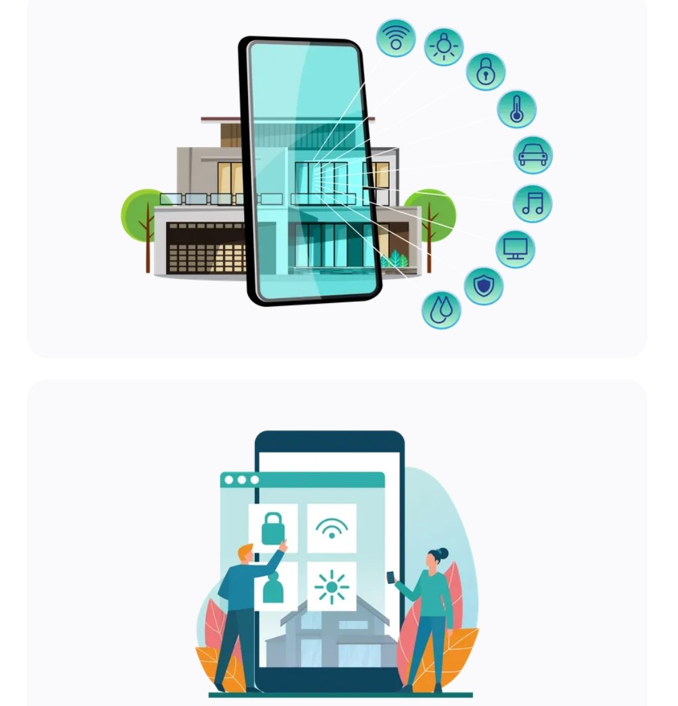

3. What is IoT?
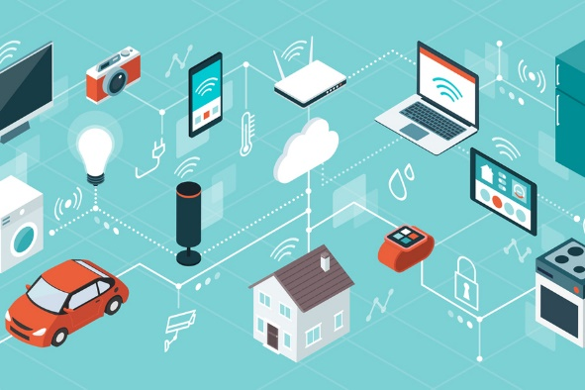
IoT stands for Internet of Things. It is an emerging paradigm that enables the communication between electronic devices and sensors through the internet in order to facilitate our lives. It has changed the traditional way of living into a high-tech lifestyle. Smart city, smart homes, pollution control, energy saving, smart transportation, smart industries are transformed due to IoT. This technology allows for the collection and sharing of data from a vast network of

devices, creating opportunities for more efficient and automated systems.

3.1 History of IoT
1982 – Vending machine: The first glimpse of IoT emerged as a vending machine at Carnegie Mellon University was connected to the internet to report its inventory and status, paving the way for remote monitoring.1990 – Toaster: Early IoT innovation saw a toaster connected to the internet, allowing users to control it remotely, foreshadowing the convenience of smart home devices.
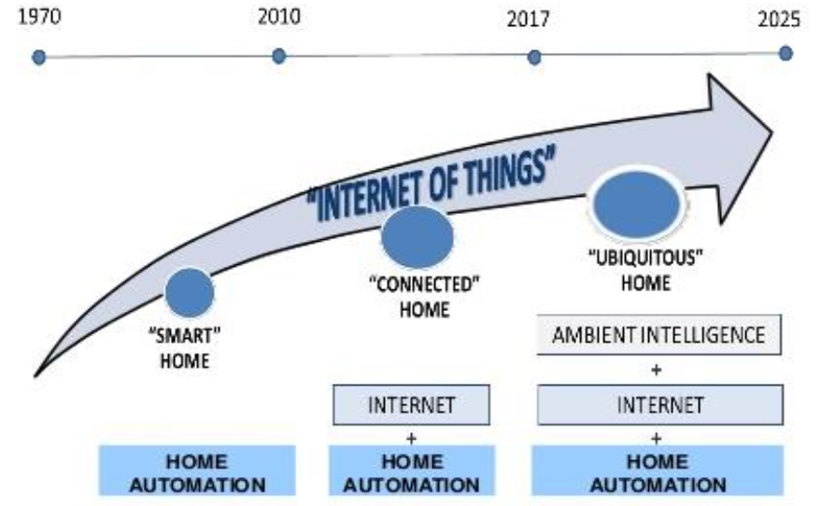
1999 – IoT Coined (Kevin Ashton): Kevin Ashton coined the term “Internet of Things” to describe the interconnected network of devices communicating and sharing data, laying the foundation for a new era of connectivity.
2000 – LG Smart Fridge: The LG Smart Fridge marked a breakthrough, enabling users to check and manage refrigerator contents remotely, showcasing the potential of IoT in daily life.
2004 – Smart Watch: The advent of smartwatches introduced IoT to the wearable tech realm, offering fitness tracking and notifications on-the-go.
2007 – Smart iPhone: Apple’s iPhone became a game-changer, integrating IoT capabilities with apps that connected users to a myriad of services and devices, transforming smartphones into hubs.
2009 – Car Testing: IoT entered the automotive industry, enhancing vehicles with sensors for real-time diagnostics, performance monitoring, and remote testing.
2011 – Smart TV: The introduction of Smart TVs brought IoT to the living room, enabling internet connectivity for streaming, app usage, and interactive content.
2013 – Google Lens: Google Lens showcased IoT’s potential in image recognition, allowing smartphones to provide information about objects in the physical world.
2014 – Echo: Amazon’s Echo, equipped with the virtual assistant Alexa, demonstrated the power of voice-activated IoT, making smart homes more intuitive and responsive.
2015 – Tesla Autopilot: Tesla’s Autopilot system exemplified IoT in automobiles, introducing semi-autonomous driving capabilities through interconnected sensors and software.

3.2 Features of IOT

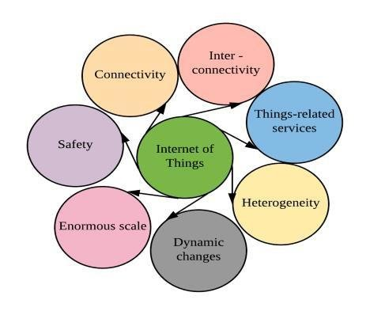
Intelligence
IOT comes with the combination of algorithms and computation, software & hardware that makes it smart. Ambient intelligence in IOT enhances its capabilities which facilitate the things to respond in an intelligent way to a particular situation and supports them in carrying out specific tasks. In spite of all the popularity of smart technologies, intelligence in IOT is only concerned as a means of interaction between devices, while user and device interaction are achieved by standard input methods and graphical user interface
Connectivity
Connectivity empowers the Internet of Things by bringing together everyday objects. Connectivity of these objects is pivotal because simple object level interactions contribute towards collective intelligence in the IOT network. It enables network accessibility and compatibility in the things.
With this connectivity, new market opportunities for the Internet of things can be created by the networking of smart things and applications
Dynamic Nature
The primary activity of Internet of Things is to collect data from its environment, this is achieved with the dynamic changes that take place around the devices. The state of these devices changes dynamically, example sleeping and waking up, connected and/or disconnected as well as the context of devices including temperature, location and speed. In addition to the state of the device, the number of devices also changes dynamically with a person, place and time.
Enormous Scale
The number of devices that need to be managed and that communicate with each other will be much larger than the devices connected to the current Internet. The management of data generated from these devices and their interpretation for application purposes becomes more critical. Gartner (2015) confirms the enormous scale of IOT in the estimated report where it stated that 5.5 million new things will get connected every day and 6.4 billion connected things will be in use worldwide in 2016, which is up by 30 percent from 2015. The report also forecasts that the number of connected devices will reach 20.8 billion by 2020.
Sensing
IOT wouldn’t be possible without sensors that will detect or measure any changes in the environment to generate data that can report on their status or even interact with the environment. Sensing technologies provide the means to create capabilities that reflect a true awareness of the physical world and the people in it. The sensing information is simply the analog input from the physical world, but it can provide a rich understanding of our complex world.
Heterogeneity
Heterogeneity in Internet of Things as one of the key characteristics. Devices in IOT are based on different hardware platforms and networks and can interact with other devices or service platforms through different networks. IOT architecture should support direct network connectivity between heterogeneous networks. The key design requirements for heterogeneous things and their environments in IOT are scalabilities, modularity, extensibility and interoperability.
Security
IOT devices are naturally vulnerable to security threats. As we gain efficiencies, novel experiences, and other benefits from the IOT, it would be a mistake to forget about security concerns associated with it. There is a high level of transparency and privacy issues with IOT. It is important to secure the endpoints, the networks, and the data that is transferred across all of it means creating a security paradigm.

3.3 IOT as Network of Networks
IOT is an emerging field which creates a vast network of interconnected devices and systems that communicate and interact together, analyse, and utilize data from the surrounding environment for the functionality and automation of the whole network.
IOT connects physical objects with separate processing, detection and activation abilities that share interaction and communication abilities using network. It’s connecting real world problem via network.
IOT (Internet Of Things) facilitates connectivity between numerous technological gadgets and sensors to improve the quality of our life. It has revolutionised the world around us.

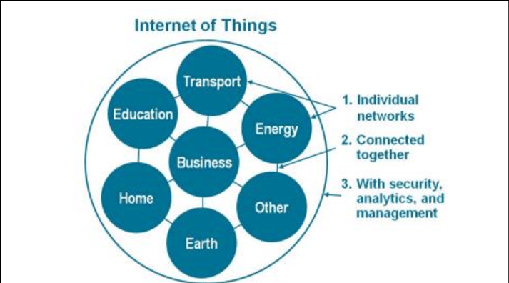

3.4 Advantages of IOT
Communication
IOT encourages the communication between devices, also famously known as Machine-to-Machine (M2M) communication. Because of this, the physical devices are able to stay connected and hence the total transparency is available with lesser inefficiencies and greater quality.
Automation and Control
Due to physical objects getting connected and controlled digitally and centrally with wireless infrastructure, there is a large amount of automation and control in the workings. Without human intervention, the machines are able to communicate with each other leading to faster and timely output.
Information
It is obvious that having more information helps making better decisions. Whether it is mundane decisions as needing to know what to buy at the grocery store or if your company has enough widgets and supplies, knowledge is power and more knowledge is better.
Monitor
The second most obvious advantage of IOT is monitoring. Knowing the exact quantity of supplies or the air quality in your home, can further provide more information that could not have previously been collected easily. For instance, knowing that you are low on milk or printer ink could save you another trip to the store in the near future. Furthermore, monitoring the expiration of products can and will improve safety.
Time

As hinted in the previous examples, the amount of time saved because of IOT could be quite large. And in today’s modern life, we all could use more time.
Money
The biggest advantage of IOT is saving money. If the price of the tagging and monitoring equipment is less than the amount of money saved, then the Internet of Things will be very widely adopted.
IOT fundamentally proves to be very helpful to people in their daily routines by making the
appliances communicate to each other in an effective manner thereby saving and conserving
energy and cost. Allowing the data to be communicated and shared between devices and then
translating it into our required way, it makes our systems efficient.
It is a boon for old and handicapped people as they are one click away from the work that they can’t do.

Automation of daily tasks leads to better monitoring of devices
The IOT allows you to automate and control the tasks that are done on a daily basis, avoiding
human intervention. Machine-to-machine communication helps to maintain transparency in the processes. It also leads to uniformity in the tasks. It can also maintain the quality of service. We can also take necessary action in case of emergencies.
Efficient and Saves Time
The machine-to-machine interaction provides better efficiency, hence; accurate results can be
obtained fast. This results in saving valuable time. Instead of repeating the same tasks every day, it enables people to do other creative jobs.

Saves Money
Optimum utilization of energy and resources can be achieved by adopting this technology and keeping the devices under surveillance. We can be alerted in case of possible bottlenecks,
breakdowns, and damages to the system. Hence, we can save money by using this technology.
Better Quality of Life

All the applications of this technology culminate in increased comfort, convenience, and better management, thereby improving the quality of life.

3.5 Disadvantages of IOT
Compatibility
Currently, there is no international standard of compatibility for the tagging and monitoring
equipment. I believe this disadvantage is the easy one to overcome. The manufacturing companies of these equipment just need to agree to a standard, such as Bluetooth, USB, etc. This is nothing new or innovative needed.

Complexity
As with all complex systems, there are more opportunities of failure. With the Internet of Things, failures could sky rocket. For instance, let’s say that both you and your spouse each get a message saying that your milk has expired, and both of you stop at a store on your way home, and you both purchase milk. As a result, you and your spouse have purchased twice the amount that you both need. Or maybe a bug in the software ends up automatically ordering a new ink cartridge for your printer each and every hour for a few days, or at least after each power failure, when you only need a single replacement.
Privacy/Security
With all of this IOT data being transmitted, the risk of losing privacy increases. For instance, how well encrypted will the data be kept and transmitted with? Do you want your neighbours or employers to know what medications that you are taking or your financial situation?
Safety
Imagine if a notorious hacker changes your prescription. Or if a store automatically ships you an equivalent product that you are allergic to, or a flavour that you do not like, or a product that is already expired. As a result, safety is ultimately in the hands of the consumer to verify any and all automation.
As all the household appliances, industrial machinery, public sector services like water supply and transport, and many other devices all are connected to the Internet, a lot of information is available on it. This information is prone to attack by hackers. It would be very disastrous if private and confidential information is accessed by unauthorized intruders.

Lesser Employment of Menial Staff
The unskilled workers and helpers may end up losing their jobs in the effect of automation of daily activities. This can lead to unemployment issues in the society. This is a problem with the advent of any technology and can be overcome with education. With daily activities getting automated, naturally, there will be fewer requirements of human resources, primarily, workers and less educated staff. This may create Unemployment issue in the society.

Technology Takes Control of Life

Our lives will be increasingly controlled by technology, and will be dependent on it. The younger generation is already addicted to technology for every little thing. We have to decide how much of our daily lives are we willing to mechanize and be controlled by technology.

4. Smart Homes
Smart home technology, also often referred as home automation or domotic (from Latin word “Domus” meaning home). It is a great transformation can be observed in our daily routine life along with the increasing involvement of an IoT devices and technology. One such development of IoT is the concept of Smart Home System (SHS) and appliance that consist of Internet based devices, automation systems for homes and reliable energy management system. Smart home consists of IoT enabled home appliances, air conditioning/heating systems, television, audio/video streaming devices, and security system which are communicating with each other in order to provide best comfort, security and reduced energy consumption.
Smart home does not only provide the in-house comfort but also benefits the house owner in cost cutting in several aspects i.e. low energy consumption will comparatively lower electricity.
A smart home is the home or that living environment having technology to allow all the household devices/home appliances to be controlled automatically and can be controlled remotely. In Smart homes user can easily monitor and control all home devices/home appliances through internet. Home appliances connect in predefined proper network architecture and using standard protocols. A smart home is one that incorporates advanced sensing and automation systems to provide the inhabitants with monitoring and control regardless of whether they are inside or outside the home. For example, a smart home may have controls for lighting, temperature, multi-media, security, window and door operations, as well as many other functions.
A Smart home, then, may be defined as a residence or a building with equipment which can be remotely controlled and operated from any location in the world by means of Smart Devices or through a smartphone. Smart Homes comprise of Devices that provide comfort, security, convenience, energy efficiency and enhance intelligent living. The Devices communicate and interact with each other and form a connected ecosystem. Smart Home is usually understood as automated home but the actual capabilities are beyond automation. Smart Home ecosystem comprises of a set of connected gadgets with Intelligence that help them in executing the task and take necessary decisions.
The first step towards making a home smart is automation as shown in Figure. The automation could be related to the individual appliances or nodes being intelligent enough to take local decisions. A simple example could be a standalone porch light that turns on only when there is movement detected or wirelessly operated curtains / blinds. Another example could be a camera that records the movements for a period of time after a gate is opened. Yet another example could be a timer in a washing machine that takes care of switching it on at preset times. A solar roof top system that charges a battery and acts as an inverter for the requirement of the individual home is also an example of an automated home system.
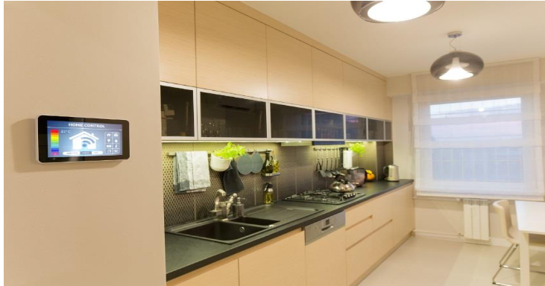
We may have another scenario where these elements are connected to each other controlled by a gadget placed inside the home (that may be called as in-home display). This connectivity could enable us to take centralized decisions and monitoring, and would make the home autonomous. These systems, even if individually smart, do not make a complete smart home. This scenario has been projected in Figure 2.
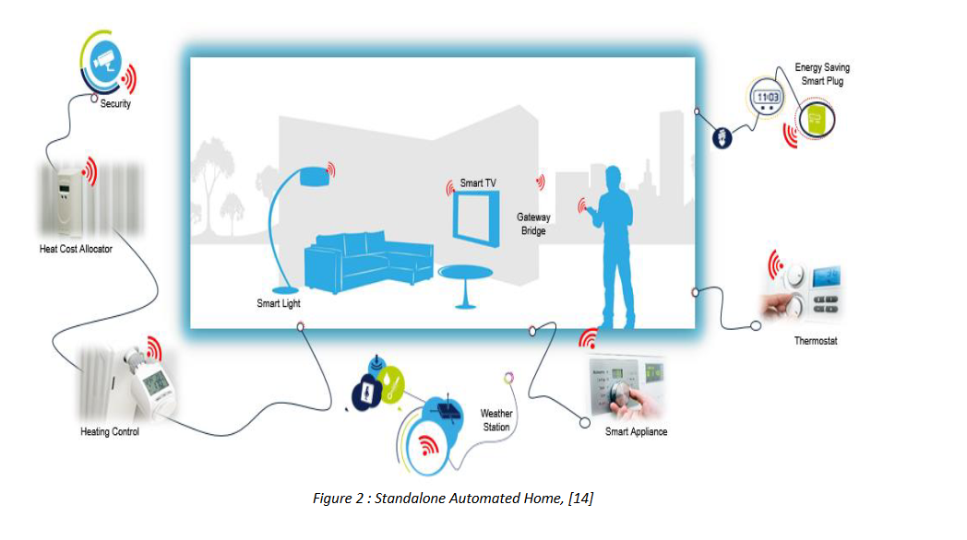
Home buildings in Indian scenario are difficult to be classified into a few categories, largely due to the economic disparity and the place of living. On one hand there is a large population that has barely access to essential requirements of water, electricity and food; and on the other India has a small percentage of population with income levels similar to those of developed countries. The expectations of comfort, automation, security and services by this population are same as those of the developed countries.
Smart Homes present some very exciting opportunities to change the way we live and work, and to reduce energy consumption at the same time. The owners of smart homes are empowered with conveniences like: being able to check messages, open windows, operate lights and curtains and monitor how much monitoring, vehicle charging, solar rooftops, metering, home appliances, electric and aircon controls, entertainment, health and fitness equipment and a host of other connected devices are part of a home and a Smart Home system is expected to provide a unified view of all these services. Smart home concept as described has been illustrated in Figure in the context of Smart Home itself being a unit of Smart City.
Extending this concept further likewise, a Smart Home in itself may be a part of a large building complex and in a much broader sense of a Smart City. This presents opportunities and challenges for connectivity and interoperability. A large number of smart devices are now available and their numbers are increasing.
At present most of the devices and gateways are working on proprietary standards. However for the fast development of the sector and to have economies of scale, devices, gateways, network and the applications are required to be developed on open standards with

interoperability. A Smart home automation system based on the internet of things (IoT) can be an efficient way to manage your home. The system can include smart devices, such as a thermostat, that are connected to the internet. These devices can be controlled through an automation system, which can make it easier to manage your home's temperature and energy use. Additionally, a smart home automation system can enhance your home's security and energy efficiency.
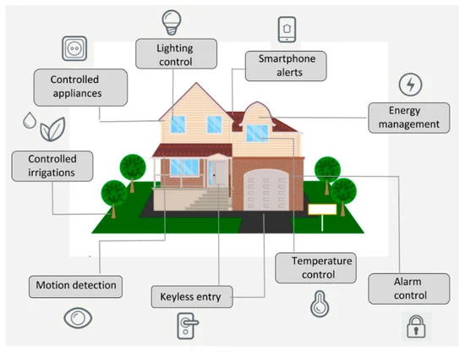
The home automation system is a mobile web-based application. This paper can be customized a lot as it has multiple GPIO port that can be programmed and they can give the user control over various things from his smart phone like security, surveillance, lighting, energy management, access control, entertainment. Home automation system should also provide a user-friendly interface on the host side, so that devices can be easily setup, monitored and controlled. The main reason to develop this system is to save time and manpower along with maintaining security and convenience. This is how an automated system proves useful to people in providing them security, comfort and easily accessible.

4.1 Smart-Home Background Analysis
As per the projections made by CISCO / ERICSSON / ITU, there may be around 50 billion connected devices globally by 2020. As per another study by CISCO in 2015, share of computers (including PCs, tablets, and smart phones) will be around 17 percent of all Internet connections; the other 83 percent will result from devices to be used in various verticals of IoT domain [3]. India is expected to have around 2.6 billion connected devices by 2020. The home automation market in India is expected to reach INR 8800 Crores (US $ 1.3 B) by 2017 and is growing at a rate of 30% CAGR.
By 2022, a typical family home will contain 500 smart devices.
The idea of Smart Home was originated long back before the advent of IoT. The world has seen a tremendous change due to the invention of various devices to automate household activities during 1901-1920. Among the few inventions of early twentieth century were first engine powered vacuum cleaner in 1901 followed by first generation of refrigerators, washing machines etc. In 1966, ECHO IV (Westing house) was the first smart device invented but was not sold in the commercial market. The device helped in automation of home appliances, controlling the room temperature and also assisted in preparing shopping list. This was followed by the invention of H316 Kitchen computer by Honeywell Corporation
that could store recipes but was not commercially available. X10, the first commercial home automation technology was developed in the year 1975 and it used electrical power transmission wire lines for signalling and communication. Bill Gates’s smart home which was built in 1995 attracted many people because of its features like temperature control, heated floors, customized preference for room lighting and climate control, monitoring his favourite Maple tree with sensors and computer to provide watering and better gardening.
The major trend has started from 1990 where home automation was the basic functionality. With the growth of smart-phones and other smart devices, the smart home penetration has increased in the world. The remote control is now embedded in smart phones in form of application to control.
Smart Homes are the integral part of Smart Cities. Connected things relevant to Smart Homes are forecasted to grow from 294 million to more than 1 billion; more than tripling in just three years, as shown in Table. Smart things inside the Smart Home are representing the biggest portion of the connected devices as per this report.
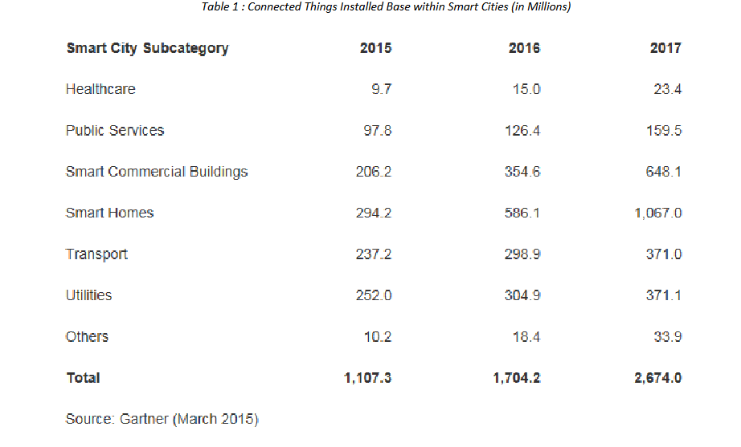
Smart Homes are the integral part of Smart Cities. Connected things relevant to Smart Homes are forecasted to grow from 294 million to more than 1 billion; more than tripling in just three years, as shown in Table. Smart things inside the Smart Home are representing the biggest portion of the connected devices as per this report.
Smart homes and smart commercial buildings represented 45 percent of total connected things in use in 2015. Due to investment and service opportunity, Gartner estimates that this will rise to 81 percent by 2020.
Homes will move from being interconnected to becoming information- and smart-enabled, with an integrated services environment that not only provides value to the home, but also creates individual-driven ambience. The home will become the personal space that provides assistance or personal concierge experiences to the individual as per Gartner report.
In a similar analysis by Statista, the growth of installed connected devices in smart homes within smart cities from 2015 to 2018 is shown in Figure.
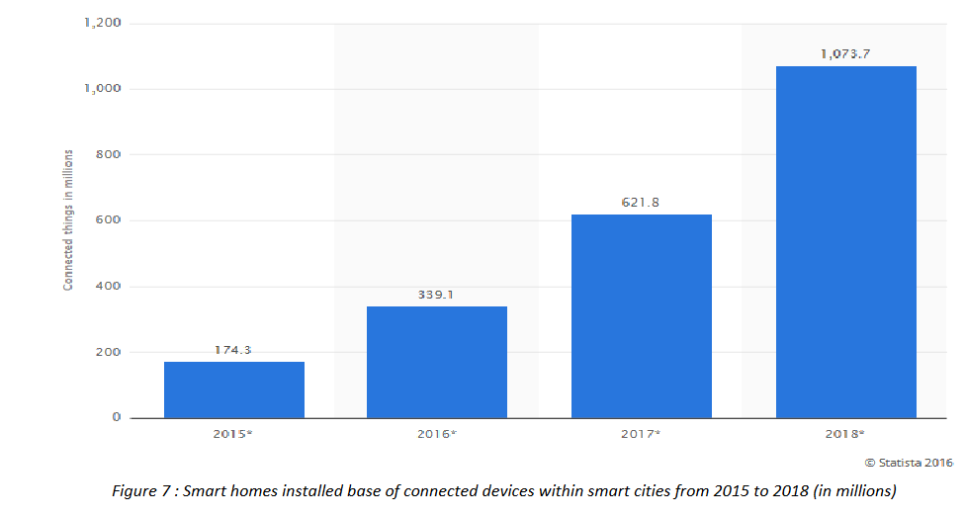
Smart homes and smart commercial buildings represented 45 percent of total connected things in use in 2015. Due to investment and service opportunity, Gartner estimates that this will rise to 81 percent by 2020. Homes will move from being interconnected to becoming information- and smart-enabled, with an integrated services environment that not only provides value to the home, but also creates individual-driven ambience. The home will become the personal space that provides assistance or personal concierge experiences to the individual as per Gartner report.

4.2 LITERATURE SURVEY
Yekhande, et. al. [4], proposed the architecture for smart home control and monitoring systems using Arduino is proposed and implemented. It gives a basic idea of how to control different home appliances and provide security by using Arduino Uno controlled from a desktop application. In our project, we tried to implement an embedded system that meets the main functions of home automation for the management of lighting, habitat security, and
Temperature & humidity control. For these reasons, a desktop application was created to interact with an Arduino via the serial port.
K Eeswari et. al., the light sensor was properly configured to detect when the laser was broken, while not accidentally tripping due to different ambient light environments. In addition, the temperature and light control subsystem outputs are confirmed to be working. Specifically, the firmware has been tested and is confirmed to be outputting the appropriate signals to the subsystem BJT switches which control lighting and furnace operations. Overall, the project has been working to design specifications and has maintained a high-quality standard which can be integrated into modern homes.
Kausalya et. al. suggest we found out that in this era of computers, smart home technology has become imminent. It’s a smart technology that gives us a different level of living standard. We are fully dependent on a system where everything is fully automatic. We are using sun tracking technology so we can get maximum efficiency of solar power. It has two different user functions; one is controlled manually and other automatically. Security is password and/or biometrically protected and sensing ability gives this home strength to protect itself.
Sahoo et. al, in this paper present a Home Automation system (HAS) using Intel Galileo that employs the integration of cloud networking, wireless communication to provide the user with remote control of various lights, fans, and appliances within their home and storing the data in the cloud. With this internet of things project, 6 you can control 4 relays from Arduino IoT Cloud dashboard, Alexa, IR remote, and manual switches.
You can also monitor the real-time room temperature in the Arduino cloud dashboard and Amazon Alexa app.
If there is no internet available still, you can control the appliances from the IR remote and switches. I have used all the FREE tools and you do not need any Alexa devices or Amazon Echo Dot for this voice control smart home IoT project.
El-Hajj M. et. al. proposed the system focuses on the a near complete and up-to-date view of the IoT authentication field. It provides a summary of a large range of authentication protocols proposed in the literature. Using a multi-criteria classification previously introduced in our work, it compares and evaluates the proposed authentication protocols, showing their strengths weaknesses, which constitutes a fundamental first step for researchers and developers addressing this domain.
Ahmed et. al introduce the system that will automatically change on the basis of sensors’ data. This system is designed to be low cost and expandable allowing a variety of devices to be controlled Such as, E-commerce, Coal Mine, Wearable device, Smart Grid, Laboratory Monitoring, Agriculture, and many other domains. The
process of controlling or operating various equipment, machinery, industrial processes, and other applications using various control systems and with less or no human intervention is termed as automation.
Kasbekar et. Al define as the Arduino UNO, ESP wi-fi module, Thing speak, relay module monitors and schedule any old electronic device through a mobile application. The process of controlling or operating various equipment, machinery, industrial processes, and other applications using various control systems and also with less or no human intervention is termed as automation. There are various types of automation based on the application they can be categorized as home automation, industrial automation, autonomous automation, building automation, etc.
“Smart Energy Efficient Home Automation System using IOT”, by Satyendra K. Vishwakarma,Prashant Upadhyaya, Babita Kumari, Arun Kumar Mishra.
This paper presents a step-by-step procedure of a smart home automation controller. It uses IOT to convert home appliances to smart and intelligent devices, with the help of design control. An energy efficient system is designed that accesses the smart home remotely using IOT connectivity. The proposed system mainly requires, Node MCU as the microcontroller unit, IFTTT to interpret voice commands, Adafruit a library that supports MQTT acts as an MQTT broker and Arduino IDE to code the microcontroller. This multimodal system uses Google Assistant along with a web-based application to control the smart home. The smart home is implemented with main controller unit that is connected with the 24-hour available Wi-Fi network. To ensure, that the Wi-Fi connection do not turn off, the main controller is programmed to establish automatic connection with the available network and connected to the auto power backup.
“IOT Based Smart Security and Home Automation”, by Shardha Somani, Parikshit Solunke, Shaunak Oke, Parth Medhi, Prof. P. P. Laturkar.
This paper focuses on a system that provides features of Home Automation relying on IOT to operate easily, in addition to that it includes a camera module and provides home security. The android application basically converts Smartphone into a remote for all home appliances. Security is achieved with motion sensors if movement is sensed at the entrance of the house; a notification is sent that contains a photo of house entrance in real time. This notification will be received by the owner of the house via internet such that app can trigger a notification. So that owner can raise an alarm in case of any intrusion or he/she can toggle the appliances like opening the door if the person is a guest. The system uses Raspberry Pi, a small sized computer which acts as server for the system. The smart home consists two modules. Home automation that consists; fan light and door controller, and security module that consists; smoke sensor motion sensor and camera module.
“A Dynamic Distributed Energy Management Algorithm of Home Sensor Network for Home Automation System”, by Tui-Yi Yang, Chu-Sing Yang, Tien-Wen Sung.
This paper proposes an optimization of home power consumption based on PLC (Power Line Communication) for an easy to access home energy consumption. This also proposes a Zigbee and PLC based renewable energy gateway to monitor the energy generation of renewable energies. ACS and DDEM algorithm are proposed for the design of an intelligent distribution of power management system to make sure ongoing power supply of home networks. To provide efficient power management the power supply models of home sensor network are classified groups viz. main supply only, main supply and backup battery, rechargeable battery power and non-rechargeable battery power. Devices with particular features are assigned to these groups. It targets to establish real time processing scheme to address variable sensor network topologies.
“Enhance Smart Home Automation System based on Internet of Things”, by Tushar Chaurasia and Prashant Kumar Jain.
This paper proposes a system that develops a model to reduce the computation overhead in existing smart home solutions that uses various encryption technologies like AES, ECHD, hybrid, etc. these solutions use intermediate gateway for connecting various sensor devices. The proposed model provides a method for automation with sensor based learning. The system uses temperature sensor for development but other sensors can also be used as per requirement. These smart home devices with sensors can configure themselves autonomously and can operate without human intervention.
This work minimizes encryption decryption and focuses on authentication and automation of smart home devices with learning. The system bypasses local gateway mentioned in existing system to provide better security for smart home devices and sensor data and save computation overhead. The real time broker cloud is directly connected with smart home and manages all incoming and outgoing request between users and devices. The main purpose to use real time broker cloud is save time of cryptographic operations.
“Visual Machine Intelligence for Home Automation”, by Suraj, Ish Kool, Dharmendra Kumar, Shovan Barman.
The paper present a vision-based machine intelligence system to sense on/off state of common home appliance. The proposed method of sensing the state of appliances results on a novel home automation system. The accessibility of the suite of devices in the home over a remote network is facilitated by the IP Addressing methods in the IOT. This project uses two boards viz. Raspberry Pi and Intel Galileo Gen 2. The communication between the User devices, Raspberry Pi and the Intel Galileo boards happens over a wireless network. The UDP protocol is deployed to facilitate the wireless communication of the nodes present in the home automation network. A Pi Cam and a USB Logitech camera attached to the rotating shaft of two different servo motor capture snapshots that are passed as inputs to the Machine Learning based models trained using dlib-C++ to detect the state
of the operation of the appliances. The proposed method uses visual modality to automate the appliances, as privacy concerns may emerge while using the images from some specific places, as a counter to this issue, an SPDT switch is added to the Raspberry Pi which when turned off ensures that even if the images are taken from the webcams, they are just passed as inputs to the machine learning models and are not displayed on the website when the users access the website on the server address obtained from Raspberry Pi.
“A Low Cost Home Automation System Using Wi-Fi based Wireless Sensor Network Incorporating Internet of Things”, by Vikram.N, Harish.K.S, Nihaal.M.S, Raksha Umesh, Shetty Aashik Ashok Kumar.
This paper illustrates a methodology to provide a low cost Home Automation System (HAS) using Wireless Fidelity (Wi-Fi). This crystallizes the concept of internetworking of smart devices. A Wi-Fi based Wireless Sensor Network (WSN) is designed for the purpose of monitoring and controlling environmental, safety and electrical parameters of a smart interconnected home. The different sections of the HAS are; temperature and humidity sensor, gas leakage warning system, fire alarm system, burglar alarm system, rain sensing, switching and regulation of load & voltage and current sensing. The primary requirement of HAS to monitor and control of devices is accomplished using a Smartphone application. The application is developed using Android Studio based on JAVA platform and User Interface of those are exemplified. The primary focus of the paper is to develop a solution cost effective flexible in control of devices and implementing a wide range of sensors to to capture various parameters.
“Voice Controlled Home Automation System using Natural Language Processing and Internet of Things”, by Mrs. Paul Jasmin Rani, Jason Bakthakumar, Praveen Kumaar.B, Praveen Kumaar.U, Santhosh Kumar.
The paper focuses on the construction of a fully functional voice based Home automation system that uses Internet of Things, Artificial Intelligence and Natural Language Processing (NLP) to provide a cost-effective, efficient way to work together with home appliances using various technologies such as GSM, NFC, etc. it implements a seamless integration of all the appliances to a central console, i.e. the mobile device. The prototype uses Arduino MK1000, known as Genuino MK1000. The NLP in this project gives the user the freedom to interact with the home appliances with his/her own voice and normal language rather than complicated computer commands. The appliances are connected to the mobile device through an Arduino Board that establishes the concept of Internet of Things. The Arduino Boards are interfaced with the appliances and programmed in such a way that they respond to mobile inputs.

4.3 TECHNOLOGY USED IN SMART HOMES
A smart home automation system based on IoT can be designed, developed, and deployed, offering residents enhanced control, automation, energy efficiency, and convenience within their homes.
Automation
Automation refers to the use of technology and machinery to perform tasks or processes with minimal or no human intervention. It involves the creation and implementation of systems or tools that can operate automatically, reducing the need for manual labour and increasing efficiency.
Home automation devices is a network of multiple devices which can serve different purpose and are offered by different vendors. Hence they are in heterogeneous in nature and there is need to have/invest multiple gateways to communicate and transform the data and push the data to cloud.
Automation can be applied to various industries and sectors, including manufacturing, logistics, finance, healthcare, and information technology. It often involves the use of robotics, artificial intelligence (AI), and computer software to streamline operations and improve productivity.
Smart
Smart is a term commonly used to describe objects, systems, or technologies that have enhanced or advanced capabilities enabled by the integration of sensors, connectivity, and artificial intelligence (AI).
IoT
The Internet of Things (IoT) refers to a network of interconnected physical devices, vehicles, appliances, and other objects embedded with sensors, software, and network connectivity that enables them to collect and exchange data. In simple terms, it is the concept of connecting everyday objects to the internet to enable communication and data sharing between devices.
A smart home automation system based on IoT can be designed, developed, and deployed, offering residents enhanced control, automation, energy efficiency, and convenience within their homes.
Wireless Communication Protocols
Smart home devices often communicate wirelessly to connect with each other and with a central hub or gateway. Popular wireless protocols used in IoT-based smart home systems include Wi-Fi, Zigbee, Z-Wave, Bluetooth, and Thread.
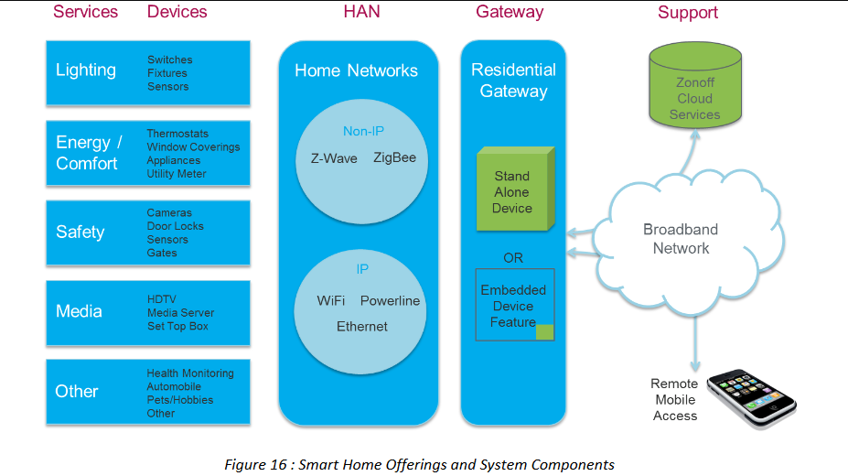

Smart Hubs/Gateways
Smart hubs or gateways act as a central control point for smart home devices.
They enable communication between various devices and provide a unified interface for users to manage and control their smart home system. These hubs may use technologies such as Wi-Fi, Ethernet, or cellular connectivity to connect to the internet and enable remote access.

Mobile Applications
Mobile apps serve as a user interface for controlling and monitoring smart home devices. These apps can be installed on smartphones or tablets, enabling users to remotely manage their smart home system, receive notifications, and customize settings.
Security Protocols
As smart home devices are connected to the internet, ensuring data privacy and security is crucial. Encryption protocols such as Transport Layer Security (TLS) and authentication mechanisms like OAuth are employed to secure communications and prevent unauthorized access to smart home systems.
Lighting
This comprises of smart lighting solutions that controls the lights of smart homes. These solutions include controlling the intensity, dimming the light, changing the schema of light in a room depending on the mood and preference of the user. Using motion detection sensors and light detecting sensors, more options can be customized like auto switch on and off, of the lights depending on proximity.
Smart Home Offerings and System Components
The various system components of a Smart Home are depicted in Figure 16 and described below.
Energy/ Comfort
These solutions include gadgets to monitor, control and use energy efficiently. Smart meters act as the fulcrum for monitoring and controlling the energy usage. Smart meters can also act as important elements in demand response, wherein, the consumption pattern of consumers is envisaged to vary as per the needs of the utility. Smart thermostats can be used to control the temperature being a critical tool for energy efficiency. Smart curtains, window coverings etc. provide a better comfort level.
Security & Safety
This is one of the crucial segment that needs to be catered. Security cameras for surveillance, smart locks that locks and opens based on preference, Smart sensors that monitor elderly people and children to estimate the activity level, are some of the offerings.
Media and Entertainment
Smart TVs are already available in market and the penetration is increasing day by day at an affordable price. These devices help to interact with the external world through IP or Wi-Fi technology and enhance the quality of living. Now YouTube and Skype can be enjoyed using a smart TV.
Hybrid Broadcast Broadband Television
Hybrid broadcast broadband TV (‘HbbTV’) is a global initiative aimed at harmonizing the delivery of broadcast TV and broadband TV to the home through connected TVs (smart TVs), set‐top boxes and multiscreen devices.
The Hybrid broadcast broadband TV specification improves the video user experience by enabling interactive services such as catch-up TV, video on demand, interactive advertising, personalization, voting, games and social networking, as well as program-related services such as digital text and M2M/IoT Enablement in Smart Homes Technical Report.

Security & Safety
This is one of the crucial segment that needs to be catered. Security cameras for surveillance, smart locks that locks and opens based on preference, Smart sensors that monitor elderly people and children to estimate the activity level, are some of the offerings.
Media and Entertainment
Smart TVs are already available in market and the penetration is increasing day by day at an affordable price. These devices help to interact with the external world through IP or Wi-Fi technology and enhance the quality of living. Now YouTube and Skype can be enjoyed using a smart TV.

Hybrid Broadcast Broadband Television
Hybrid broadcast broadband TV (‘HbbTV’) is a global initiative aimed at harmonizing the delivery of broadcast TV and broadband TV to the home through connected TVs (smart TVs), set‐top boxes and multiscreen devices.
The Hybrid broadcast broadband TV specification improves the video user experience by enabling interactive services such as catch-up TV, video on demand, interactive advertising, personalization, voting, games and social networking, as well as program-related services such as digital text and electronic program guides.
Hybrid broadcast broadband TV uses a single user interface. This creates an open platform as an alternative to proprietary technologies, which increases user choice.
Hybrid broadcast broadband TV is easy to implement and compatible with other hybrid TV technologies such as MHEG-5. Products and services using the Hybrid broadcast broadband TV standard can operate over different broadcasting technologies, such as satellite, cable and terrestrial networks. Hybrid broadcast broadband TV is being deployed globally. A broad set of Internet and broadcast services have already been tested and implemented.
Miscellaneous Services
These services include features like E-health, Tele-medicine etc. These services help focusing individual health and allied services. With these services, the patient’s health report can be sent to a doctor at regular time intervals, who can suggest meaningful proper medication which makes the statement Prevention is better than Cure much more clearer. Also these can be used for life critical services like whenever the patient is down or severely ill, these gadgets can be used to gather attention or send SOS mails to the configured number and help save life.
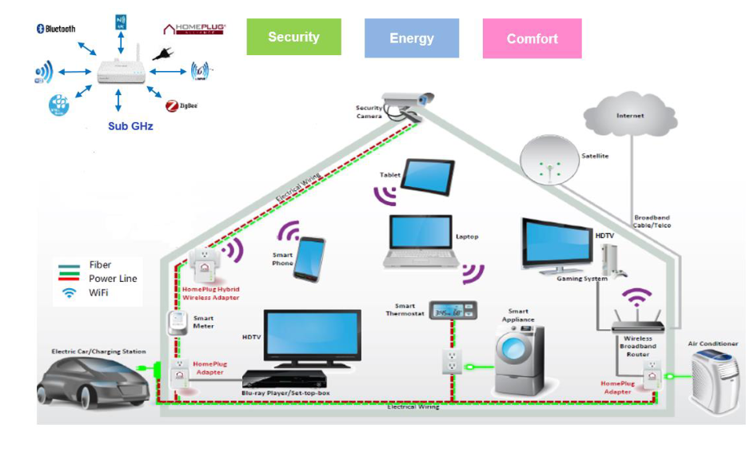

4.4 How does smart home technology work?
A smart home isn't a collection of disparate smart devices and appliances, but rather ones that work together to create a remotely controllable network. All devices -- such as lights, thermostats, security systems and appliances -- are controlled by a master home automation controller, often called a smart home hub. This hub is a hardware device that acts as the central point of the smart home system and can sense, process data and communicate wirelessly. It combines all the disparate apps into a single smart home app that homeowners can control remotely. Examples of smart home hubs include Amazon Echo, Google Home and Wink Hub. While many smart home products use Wi-Fi and Bluetooth to connect to the smart home network, others depend on wireless protocols such as Zigbee or Z-Wave.
Smart home devices can be either programmed to follow specific schedules or commands or they can be set to respond to voice commands through home assistants such as Amazon Alexa or Google Assistant. For example, a smart thermostat can learn the homeowner's habits and automatically adjust the temperature based on their specific schedule.

4.5 IoT architecture and technologies
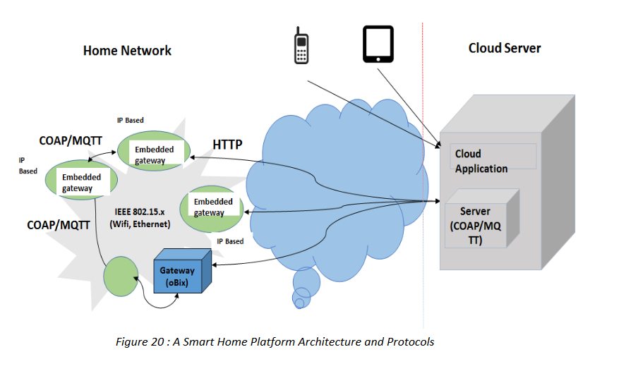
The IoT architecture consists of five important layers that defines all the functionalities of IoT systems. These layers are perception layer, network layer, middleware layer, application layer, business layer.
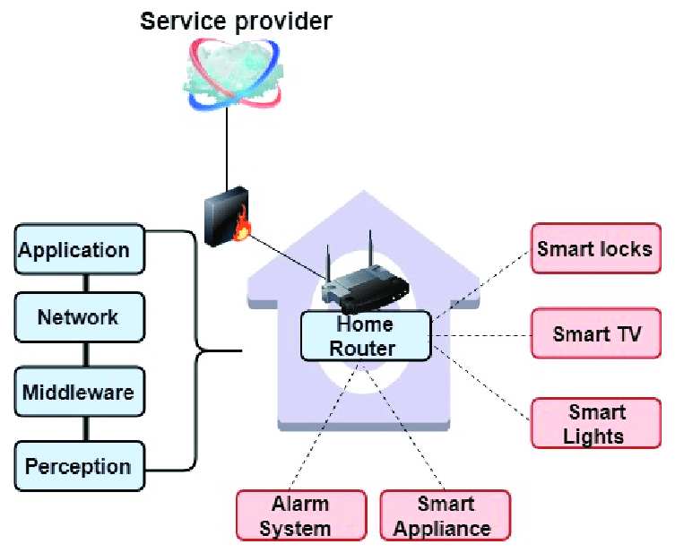At the bottom of IoT architecture, perception layer exists that consists of physical devices i.e. sensors, RFID chips, barcodes etc. and other physical objects connected in IoT network. These devices collects information in order to deliver it to the network layer. Network layer works as a transmission medium to deliver the information from perception layer to the information processing system. This transmission of information may use any wired/wireless medium along with 3G/4G, Wi-Fi, Bluetooth etc. Next level layer is known as middleware layer. The main task of this layer is to process the information received from the network layer and make decisions based on the results achieved from ubiquitous computing. Next, this processed information is used by application layer for global device management. On the top of the
architecture, there is a business layer which control the overall IoT system, its applications and services. The business layer visualises the information and statistics received from the application layer and further used this knowledge to plan future targets and strategies. Furthermore, the IoT architectures can be modified according to the need and application domain.
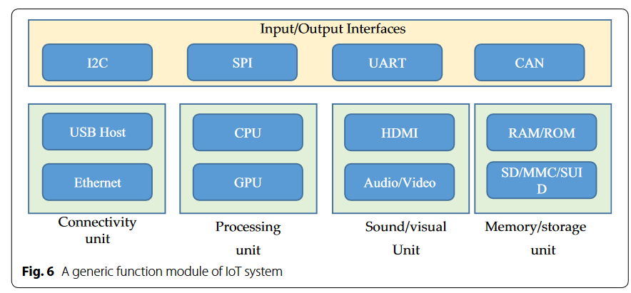
Besides layered framework, IoT system consists of several functional blocks that supports various IoT activities such as sensing mechanism, authentication and identification, control and management. Figure illustrates such functional blocks of IoT architecture.
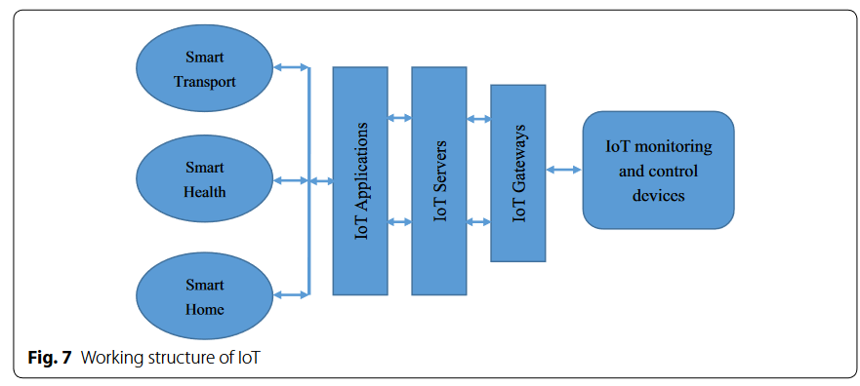
There are several important functional blocks responsible for I/O operations, connectivity issues, processing, audio/video monitoring and storage management. All these functional block together incorporates an efficient IoT system which are important for optimum performance. Although, there are several reference architectures proposed with the technical specifications, but these are still far from the standard architecture that is suitable for global IoT [39]. Therefore, a suitable architecture is still needs to be designed that could satisfy the global IoT needs. The generic working structure of IoT system is shown in Fig. Figure shows a dependency of IoT on particular application parameters. IoT gateways have an important role in IoT communication as it allows connectivity between IoT servers and IoT devices related to several applications.
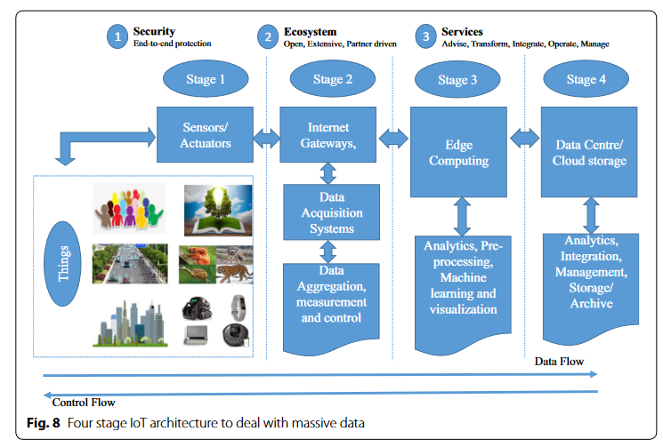

5. Application of IOT in Smart Homes

Smart thermostats
IOT enabled smart thermostats can learn your temperature preferences and automatically adjust the temperature of your home to save energy. They can also be controlled remotely via smartphone app.
Smart lighting
IoT enabled smart lighting systems can be controlled via a smartphone app, allowing you to turn lights on and off, adjust brightness, and change colours remotely. They can also be programmed to turn on or off at specific times or when you enter or leave a room.
Smart locks
IoT-enabled smart locks can be controlled via a smartphone app, allowing you to lock or unlock your doors remotely. They can also be programmed to unlock automatically when you arrive home or lock automatically when you leave.
Smart home security systems
IoT-enabled home security systems can include cameras, sensors, and alarms that can be monitored and controlled remotely via a smartphone app. They can also send alerts to your phone if there is unusual activity in your home.
Smart appliances
IoT-enabled smart appliances, such as refrigerators, washing machines, and ovens, can be controlled via a smartphone app. They can also be programmed to optimize energy consumption and reduce waste.
Voice assistants
IoT-enabled voice assistants, such as Amazon Alexa or Google Assistant, can be integrated with smart home devices to allow for voice control. This allows you to control your devices hands-free. By incorporating IoT technology into their homes, homeowners can enjoy greater convenience, energy efficiency, and security. They can also save money on energy bills and reduce their environmental footprint.
Intrusion Detection
Home Intrusion Detection systems use security cameras and sensors to detect intrusion and raise alerts. Alert can be informed by an SMS or an email sent to the user. Advance systems can send detailed alerts such as an image shoot or short video clips.
Smoke/gas Detectors
Smoke detectors are installed in homes and buildings to detect smoke that is typically an early sign of fire. It uses optical detection, ionisation for Air sampling techniques to detect smoke.
Gas detectors can detect the presence of harmful gases such as CO, LPG, etc. It can raise alerts in the human voice describing where the problem is.

6. Major Trends in Global Smart Home Market

Figure shows the concept of Smart Home in another manner in an immersive experience to the user. Various trends in the global market are explained below.
Global IoT segments are growing- Smart Home is becoming a trend
M2M/IoT technologies are proliferating and Smart Homes vertical is witnessing a major action. Variety of sensors that can be easily connected to the cloud at affordable prices are resulting into this proliferation.
Investment Research & Development
The connectivity technologies for home are the ones that are applicable in other sectors as well. This helps every sector to enjoy the benefit of the technological advancements. Smart Home sector is getting attention of major players. Players like Google, Apple, Nest Labs, Amazon (Echo), AT & T (Digital Life), Xiaomi, Xfnity (Comcast) etc are already having their offerings in this sector.
Trend in Smart Wearable Devices with Smart homes
Smart Gadgets with Augmented reality and Virtual reality platforms are now interacting with customers in day-to-day life. As these wearable gadgets are closely associated with the users, the Smart Home value chain players are targeting these smart gadgets for integrating their smart appliances.
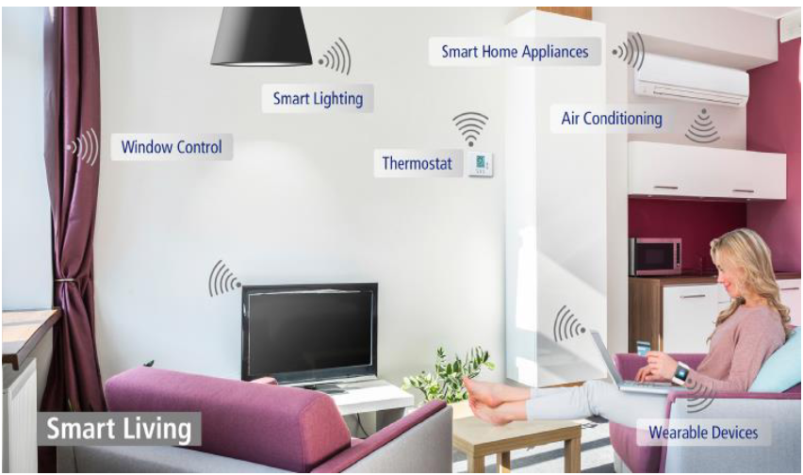

Convergence of Consumer and Enterprise Technology.
Mobile consumer and enterprise technologies are converging in most industries. Smart Home will be equipped with features similar to that of an enterprise. Analytics, Smart TV, Gadgets will be a part of this ecosystem. A parallel to this can be drawn with the fact that earlier, automation or surveillance was part of only commercial buildings earlier but it has started to become a requirement in an ordinary home today
Smart Homes and Automobile market
Smart home scope is getting extended to automobiles too. Many automobile manufacturers like Ford, Toyota are working to synchronize their automobile with smart home gadgets. Most of them have invested in their R&D to establish a fool proof system. A Smart Home will provide not only charging to the automobile in case of Electric Vehicles, but may also be powered by it in certain situations. An automobile roof may provide solar power to home or for net metering in future.

6.1 Major Technology Trends

Décor- Friendly Gadgets
The gadgets are aesthetically more appealing than normal gadgets. This helps to make a fashion statement as good sensors/nodes placed at various locations in the house are considered as desirable elements. The small size further adds to this feeling.
Programmable Devices
The smart gadgets can be programmed and customized according to the user preference. For example, programmable thermostats that can be controlled using the smart gadgets and can be used to control the temperature based on occupancy. The programming capability also adds to personalization.
Wireless controls
More and more devices are now connected through wireless. This makes the installation simpler. A further element of wireless is portability as devices or nodes can be moved easily to another location in the house or to another house.
Advanced Security Systems
The Smart Home gadgets provide a better home automation with enhanced security. These gadgets can track the activity of human beings especially monitoring children and elderly people and activate the security systems in case of an emergency. Security systems and remote monitoring can be further thought to aid remote patient care also.
Automated door locks
The automated door locks are configured in such a way that these doors unlock based on the user and his access criteria. These smart locks can be configured with wearable gadgets also. These are considered to be aiding to safety also as depending on the category of the visitor, one may unlock the lock for different time durations and auto lock when needed. The remote door locks are expected to create several different use cases and at present these are in various stages of experimentation even if deployment has already started.
Smart Appliances
Currently, household appliances are responsible for about two thirds of the energy consumed by buildings. Industrial appliances are also major energy users. In the future, such appliances will no longer be stand-alone items. By communicating between themselves and with energy control systems, the impact of these devices on the environment can be managed and optimized. Smart appliances will include white goods, heating, ventilation and air conditioning systems and storage systems.
Solar Roof tops
It is pertinent to mention that roof-top solar, net metering and electric vehicles would play a huge role in the Smart Home, thereby creating a micro grid. Electric vehicles would not only provide a clean and efficient means of transport, but would act as virtual power plants which could supply power to the grid in case of an outage.
Wearable Devices
Furthermore, with the proliferation of wearable devices for improved healthcare, the quality of life of citizens will substantially enhance.

7. Challenges and their solutions

Lack of standards and interoperable technologies
Industries are working in silos and on proprietary solutions. For the smooth development of the vertical and also to have economies of scale, devices based on open standards should be used. Interoperability is required at all levels,be it device, network or application level.
Technologies for low power consumption
It is are required for ensuring longer life for batteries especially in case of wearable devices. This becomes especially important as these devices are required to be usually equipped with some kind of wireless to be able to communicate with the nearest available authorised gateway or master.
Slow deployment of IPv6
In view of high volume of devices being deployed and expected to to be deployed in M2M/ IoT domain, the device and Gateways connected directly to PLMN or PSTN network should have IPv6 or a seamless mix of IPv4 and IPv6. As IPv4 are going to exhaust, early adoption of IPv6 will be better.
Low cost devices (affordability)
The adoption and penetration of smart devices is still less and the cost is high. This is partly due to the fact that proprietary devices are being sold from multiple vendors. This often requires specific implementation for specific use case. Standardization is necessary in order to bring down the costs and ensure interoperability as discussed above.
Data Security & Privacy
As larger number of devices are getting connected in the home, security and privacy are becoming increasingly important for the consumer. Whether it is businesses using behavioural data for their own commercial purposes, or criminals illegally hacking into and controlling the devices connected to the home network, consumers need to feel confident that they are adequately protected from any malpractices. For this, end to end security is required with security features implemented at all levels.
Health care regulations
It is required for use of wearable health devices for remote monitoring of vital parameters of the individual / patient at home. It will be helpful in reducing the burden on the hospitals.

High speed and reliable internet services
For the development of Smart home / connected home vertical, there is a need of high speed and reliable interned services on fixed line broadband as well as mobile connections. All the data from smart devices can be assumed to be concentrated on a single pipe from the home. High speed is important but reliability and availability are equally important for faster adoption of the services.
Smart home gateways
They are having multiple protocols for HAN is required as the appliance may be having different types of communication protocols.
Fragmented Market
Fragmentation slows down market development as the vendors’ hedge their bets on which technologies to back. It also increases equipment costs as multiple solutions need to be incorporated, and leads to consumer frustration when solutions do not work together.
Cost of Implementation
Introducing more and more connected devices into the home is an expensive business for the average consumer. While costs remain high, implementation of many solutions will remain limited – especially ones that do not provide any perceived real value.

A WAY FORWARD
Looking at various aspects, it is clear that there are positive elements present that are
supporting and encouraging the adoption of M2M in the context of Smart Homes and also there are bottlenecks as pointed out in the previous sections. The following are the suggestions and Way Forward that this group suggests:
Unified Gateway is required to be developed having Wi-Fi and Sub GHz based network (Z-wave, 6LoWPAN, BLE etc) in the home area and fixed line broadband / FTTH / cellular on the WAN. Gateway should be based on open standards and with static IP capability (preferably IPv6/ dual stack)
Existing BB modems working on fixed lines / FTTH may be converted to Gateways by adding additional hardware module via the existing either of the available ports like serial, Ethernet, USB or Wi-Fi etc. An additional memory thus could be used to create a home network in the sub-GHz band (for Z-wave / 6 LoWPAN etc) depending upon the requirement. This requires further feasibility as adding a module to the existing devices would require the design details of the existing devices.
Indigenous technologies may be developed in the Sub GHz band.
TEC may work on point no. 1 and 2 for creating GR / IR based on related standards.
Standards for the common service layer are required.
- Your Smart Device Drains it’s Batteries Too Fast

Wireless smart home products are great until you realize that wireless devices require maintenance. Door sensors and other low-energy products typically need fresh batteries only every year or two, but cameras and motion sensors can chew through batteries at a much faster rate. A dead smart home gadget is a useless smart home gadget.
Solution:
Check your device’s settings and make sure you’re in range of a good Wi-Fi signal. Just like your smartphone, your smart devices will run their batteries dry a lot faster if they’re constantly looking for a signal or straining to maintain one. Moving your devices just a few feet closer to your home’s network can have a dramatic impact on their battery life.
If you dig into your device’s settings, you’ll also discover many optional features that can be toggled off for increased efficiency. Keep the features you use the most and turn the ones off that you never use; it’ll help extend the life of your battery.

- Your smart home devices activate at the wrong time

Nothing is worse than a smart gadget that constantly demands your attention for all of the wrong reasons. This is especially true of smart security cameras and sensors. Security products should be trustworthy, and it’s frustrating to get security alerts on your phone that are just false alarms from three branches blowing in the wind or a cat jumping on the furniture.

Solution:
Take advantage of the smart zones and features like human recognition. Many smart cameras can ignore certain parts of your home or yard that experience frequent motion, and sometime include toggles for a feature where you will be alerted only if an unidentified person is detected in the frame. Some systems are powered by artificial intelligence to pinpoint and zoom in on motion and can send the video clip of the activity. It takes only seconds to customise your cameras but it can have a noticeable impact oh how effective they are.

- Your Smart Home Device Is Hard to Control
Although the other issues we’ve covered are fairly common, the most common complaint with families adapting to smart home technologies is that they hate feeling confined to an app to control their homes. It’s great being able to set the temperature or control your lights from anywhere in the world, but when you’re having a normal day at home, it can be a chore to track your phone down every time you want to make a simple adjustment to your living space.
Solution:
Make sure the smart devices you purchase have easy-to-access physical controls, and consider investing in a few smart switches. The best smart thermostats and door locks include traditional controls that work in conjunction with their companion apps, allowing your family to have all of the benefits of a smart device while interacting with it like its traditional counterpart. For devices like smart lighting systems that are controlled exclusively through an app or touchscreen panel, inexpensive smart switches are also available that can allow your family to toggle those controls with the click of a button.

- Your smart home device can’t connect to the network
Network connectivity is one of the most common issues that the smart device owners will encounter. From smart cameras dropping the feed, to your living room smart lights failing to turn off, connectivity issues can be annoying and even seriously disruptive. The good news is that this issue is extremely easy to fix.

Solution:
Upgrade to a better wireless router, and make sure your Zigbee and/or Z-Wave devices aren’t too far apart. Your wireless router is the backbone of your smart home, and if you haven’t upgraded in a while, your trusty old router will probably have a hard time keeping up with so many devices on the network. Upgrade to a top-of-the-line router from the hardware store or get it from your local Internet service provider. If you live in a large home or apartment, you may want to consider setting up “mesh networking” to ensure consistent Internet connectivity throughout your home.
If you choose devices like door locks or light bulbs that rely on protocols like Zigbee or Z-Wave, make sure those devices aren’t spread out too far from each other. Those devices actually piggyback off of each other’s signals, meaning that products like smart light bulbs may have connectivity issues if they’re connected at the opposite ends of your home.

- Your Smart Home Devices Don’t Play Together
With so many smart home gadgets to choose from, the first issue you’ll likely run into is purchasing the thermostats, security cameras, and sensors that you like the most, only to find out that they don’t automatically work together. Although almost every smart home device connects to a companion smartphone app, the best experience is being able to open a single app or use a single service that enable you to manage and control all of your smart gadgets at once.
Solution
Invest in a smart home hub. Your local cable or Internet service provider may be able to help you set up a full home automation system that works as one that you can control via one hub and one mobile app. You can also look into web services like Stringify or IFTTT. Many of today’s smart home products integrate with the most popular smart home hubs, allowing you to use and schedule your favourite devices to turn on and off from a single app, instead of bouncing back and forth between a folder full of apps for each device. If all else fails, free web services like Stringify can link up with most smart home gadgets, allowing you to cook up some great integrations with products that don’t automatically play nice together. This means you can program lights and the TV to turn on when the AC is on, etc. The combinations are endless, depending on the devices you have.

8. Future scope of IOT in Smart Homes

With the evolution of the converged & networked society, further fuel by the ‘Internet of Things’ era, a multitude of new applications of the Information& Communication Technologies have changed the way we live, work, play, interact and even think. The Smart Home paradigm’s true evolution & proliferation depends entirely on the End-to-End interoperability. Just like our Electrical Plugs, Sockets, Switches, Lamps and Lamp Holders etc.; or like the IT & Networking equipment. Any component/part of one Make can be replaced by the same part from any other manufacturer by the consumers themselves without any compatibility issues. The situation becomes much more complex when we consider Smart Homes in context of Smart Cities & Smart buildings. A major disconnect which has recently become apparent is: the technological trends in ‘Smart Homes’, ‘Smart Buildings’, ‘Smart Cities’ and ‘Smart Grid’ are being considered and pursued in isolation from each other with ‘silo’ approach, by the respective stake holders.
In fact, they form a very tightly interwoven and homogenous confluence of similar technologies being applied in different domains for a common cause of making our planet earth ‘smart, green and secure’.
Each application ecosystem like smart home, smart building, smart street lighting and smart grid have, over the years, developed their own respective sets of standards and last mile communication protocols.
Even some ecosystems like smart grid and smart home have got multiple sets of standards and protocols being advocated as the most appropriate for their respective applications.

SMART BUILDINGS
At the most fundamental level, smart buildings deliver useful building services that make occupants productive (e.g. illumination, thermal comfort, air quality, physical security, sanitation, and many more) at the lowest cost and environmental impact over the building lifecycle. Reaching this vision requires adding intelligence from the beginning of design phase through to the end of the building’s useful life.
Smart buildings use information technology during operation to connect a variety of subsystems, which typically operate independently, so that these systems can share information to optimize total building performance. Smart buildings look beyond the building equipment within their four walls. They are connected and responsive to the smart power grid, and they interact with building operators and occupants to empower them with new levels of visibility and actionable insight and information.
Enabled by technology, the smart building connects the structure itself to the functions it exists to fulfil
• Connecting building systems
• Connecting people and technology
• Connecting to the global environment
• Connecting to the smart power grid
• Connecting to an intelligent future.

SMART CITY
The relationship between Smart Grids and Smart Cities needs to be understood in this context: In a smart city, energy, water, transportation, public health and safety, and other key services are managed in concert to support smooth operation of critical infrastructure while providing for a clean, economic and safe environment in which to live, work and play. Hence, the perspective in Infrastructure Design for any city has undergone a paradigm shift with advent of convergence and networking technologies, solutions for information, communication, entertainment, security and surveillance; which are beginning to have a profound impact on the way we look at the buildings’ design (be it residential or commercial) and town planning.
Cities are intricate composite environments and the manner in which cities are operated, financed, regulated and planned are extremely complex to say the least. City operations are multidimensional and comprise of multiple stakeholders whose dependencies and interdependencies affect and ultimately determine the built environment.

9. Conclusion
With the emergence of information and communication technologies (ICT) and the development of advanced sensing systems, the concept of smart home is receiving a growing attention worldwide. In past decades, smart homes were generally conceptualized as an innovative dream for future built environments. Nevertheless, this study demonstrated the growing interest in this field and confirmed the penetration of smart homes into urban areas, stressing that smart homes are gradually entering our lives. This study attempted to provide a holistic overview about the current status and future direction of smart homes. It was found that smart homes are predominantly influenced by the integration of ICT and intelligent technologies such as sensors and actuators. With the aid of technology, smart homes are capable of ensuring an independent lifestyle for all users with higher level of safety, security and comfort through continually monitoring and controlling the users’ activities, behavioural patterns, health status of patients and automatically responding to the needs and preferences of occupants. Moreover, smart homes are able to cast sufficient control over household energy consumption resulting in an energy efficient living environment as an important criterion for achieving a sustainable urban future.
Smart home promise to create adaptive, supportive and assistive living environments. Likewise, smart home holds great promises for rectifying the major concerns towards the building sector according to its potentials in managing the building energy consumption, dealing with the environmental issues, and offering consistent health monitoring and controlling. Smart homes can be considered a promising solution for the future of AEC industry according to their flexibility, adaptability and dynamic features. Traditionally, residential buildings are not flexible enough to correspond to the diversity of users’ demands. They generally follow a singular pattern to meet the residents’ demands. As such, several issues can be derived from this inflexibility. These include increasing the energy consumption and environmental emissions. However, smart homes can revolutionize the traditional relationship between users and homes. They increase the level of users’ participation in controlling the household energy consumption. Smart homes can be responsive/interactive towards the residents’ needs. They deliver a consistent health caring, monitoring and control system. They provide a behavioural map and respond to any detected deviations from the developed pattern. Furthermore, smart environments recognize the level of users’ activities in buildings and regulate the household energy consumption based on users’ presentence. Smart homes improve the static relationship between users and traditional buildings to a flexible and interactive one. Smart homes should improve the linkages and communications between the occupants and the living environments resulting in ensuring a highly independent and convenient lifestyle. In recent years, smart homes were mainly introduced as highly automated living environments through deploying sophisticated technologies. However, future research should draw more attention to the environmental performance of smart homes for ensuring a significant contribution to the current endeavours towards creating greener and smarter cities. In near future, smart homes will become more intertwined with ‘adaptability’, ‘self-adjustability’, and ‘self-learning capability’ features in order to automatically respond to the entire needs of users and local contexts. With the high costs of the existing intelligent technologies as a key challenge, governmental sectors and policy makers are highly recommended to develop new initiatives such as incentivized programs for the proliferation of smart homes into future urban areas. The findings encourage scientists and researchers to focus on the further exploration and analytical evaluation of the social and environmental benefits of smart homes by using cross-disciplinary collaborative approaches from the viewpoints of architects and urban planners as well as civil, environmental, mechanical and computer engineers. Furthermore, future research is necessary to evaluate possible policies for encouraging the use of smart homes. Finally, further investigations towards ensuring the economic feasibility of the proliferation of smart homes as part of the urban sustainability agendas should be encouraged.

10. BIBLIOGRAPHY
- A. A. Zaidan, B. B. Zaidan, M.Y. Qahtan, O.S. Albahri, A.S. Albahri, Mussab Alaa, F.M. Jumaah, Mohammed Talal, K.L. Tan, W.L. Shir, C.K. Lim ‘‘A survey oncommunication components for IoT based technologies in smart homes,’’. Telecommunication. Syst., vol. 69, no. 1, pp. 1–25 ( 2018).
- P. Gupta and J. Chhabra. ‘‘IoT based Smart Home design using power and security management", International Conference on Innovation and challenges in cyber security (2016)
- S. Badabaji, V. S. Nagaraju. ‘‘An IoT based smart home service system", International journal of pure and applied mathematics volume 119 No.16 pp.4659 - 4667 (2018.)
- E. N. Ganesh, ‘‘Implementation of IOT architecture for SMART HOME using GSM technology", International journal of computer techniques Volume 4 Issue 1 (2017)
- D. Anandhavalli, Noorul S.Mubina, Bharathi.P “Smart home automation control using Bluetooth and GSM", International Journal of informative and futuristic research pp 2547-2552 (2015)
- Labus, B. D. "A smart home system based on sensor technology" Facta Universitatis, Electron. Energetics, Vol.29 No.3 pp.451 - 460 (2015)
- M. L. Sharma, Sachin Kumar, Nipun Mehta ‘‘Smart home system using IoT", International research journal of engineering technology vol.4 issue 11(2017).
- D. M. Konidala, ‘‘Security frame work for RFID-based applications in smart home environment,’’. vol. 7, no. 1, pp. 111–120 (2011)
- N. David, Abafor Chima, Aronu Ugochukwa, Edoga Obinna “Design of a home automation system using arduino", International journal of scientific and Engineering research, Volume 6, Issue 6 (2015)
- 10. N. Kodali, and S. Soratkal ‘‘MQTT based home automation system using ESP8266", IEEE region 10 Humanitarian technology conference (2016)
- https://www.researchgate.net/publication/355171645_IoT-Based_Integrated_Smart_Home_Automation_System"

